Gradient Descent For Multiple Variables

**Gradient Descent for Multiple Variables**

The gradient descent equation itself is generally the same form; we just have to repeat it for our 'n' features:

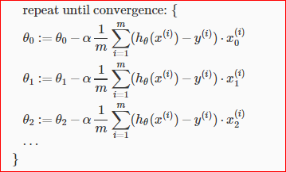

In other words:

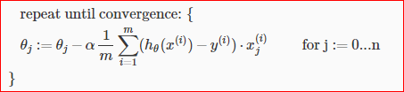

The following image compares gradient descent with one variable to gradient descent with multiple variables:

